**Master Functional Document**

|  |  |
| --- | --- |
| **Application** | NGERP - Centra |
| **Service Bundle** | Master Management |
| **Service Request** | Gift Product |

**Description:**

Gift Product in Compiere NGERP-Centra refers to products designed for promotions or gifting. They may include details such as Bill of Materials, discontinued status, and shelf life. These products are managed within specific product categories with rules for inventory control and tracking.

**Workflow Process:**

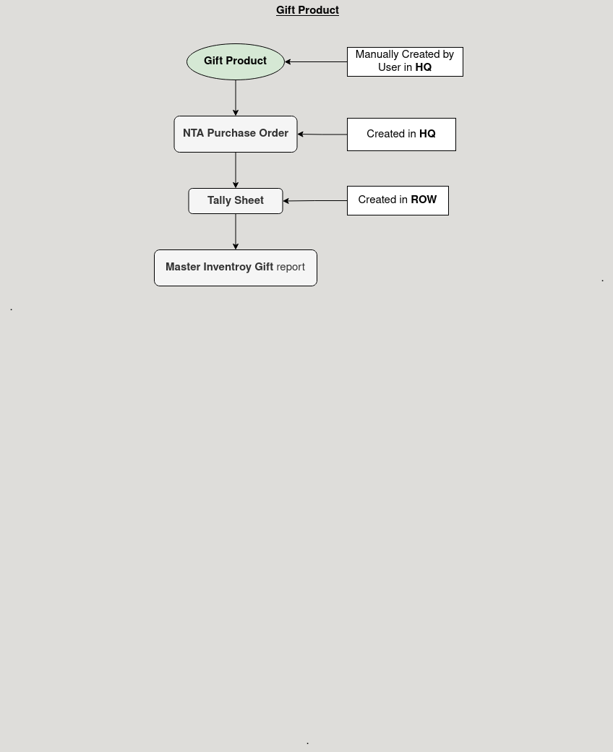

**Business Rules:**

* It is visible in both **HQ** and **ROW.**
* **Creation** is possible only in **HQ.**
* Product Size such as Bottle, Package, or Sachet defines packaging options for better inventory control.
* Shelf Life determines the expiration period, impacting product availability for sale and delivery.
* Purchased indicates whether the organization buys the product from external vendors or produces it in-house.